Assignment9

Create a repo in GitLab > testproject

Create a folder folder1 on your system

Add 2 files > file1, file2 in that

push it to testproject repo in GitLab

Clone on your system only in some other path

Add 2 more files in folder1

push them again to remote repo

Download only changed content in the folder created after clone

1st step Created files Locally :

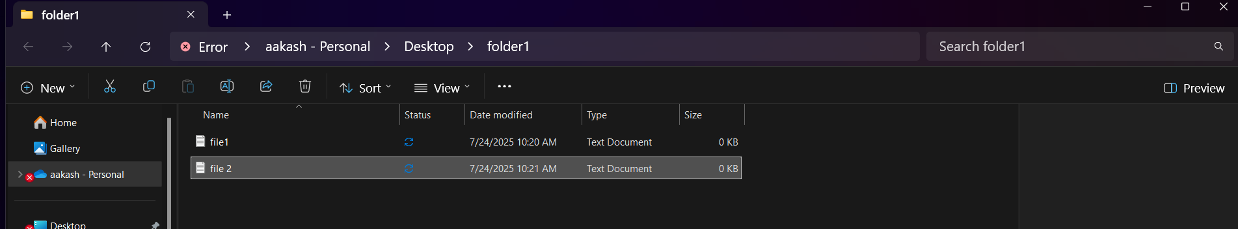

2nd step Created a Repo in GitLab:

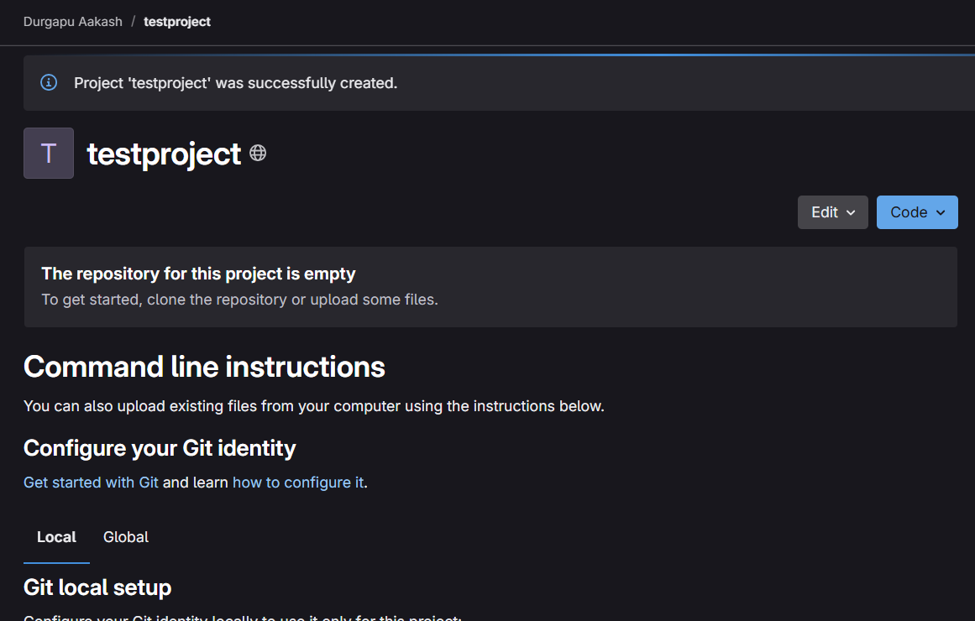

Initializing Git:

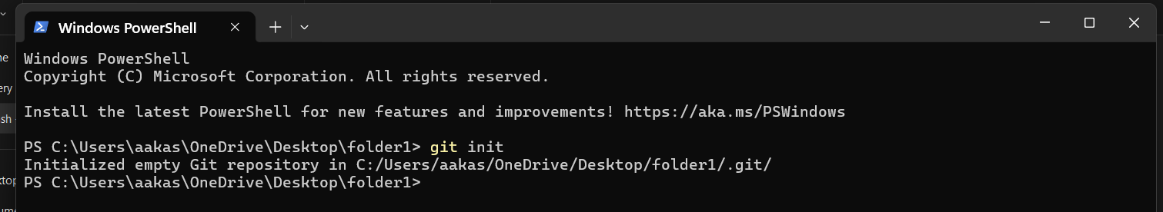

Added to git:

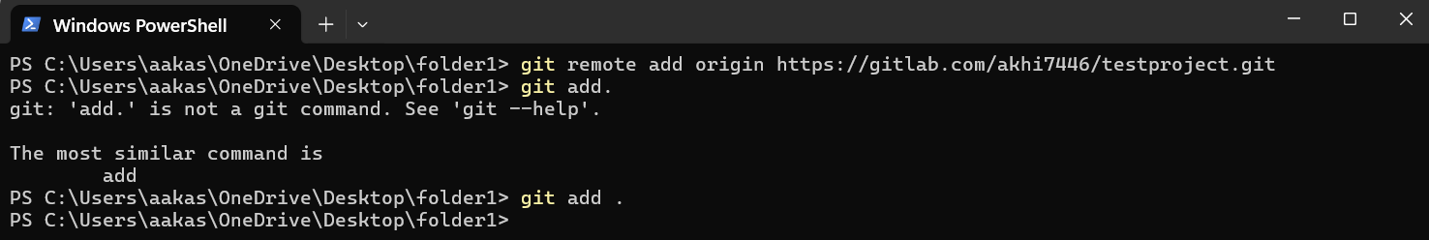

Git Commit: 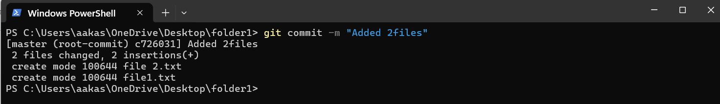

Git Push:

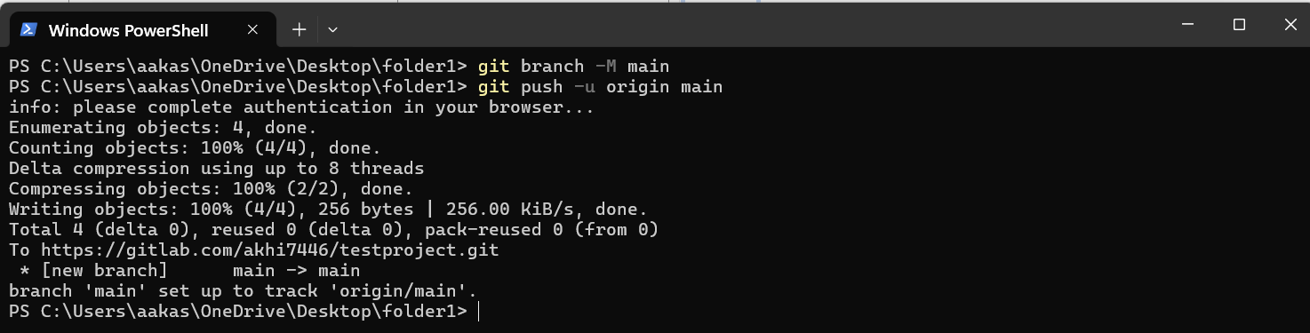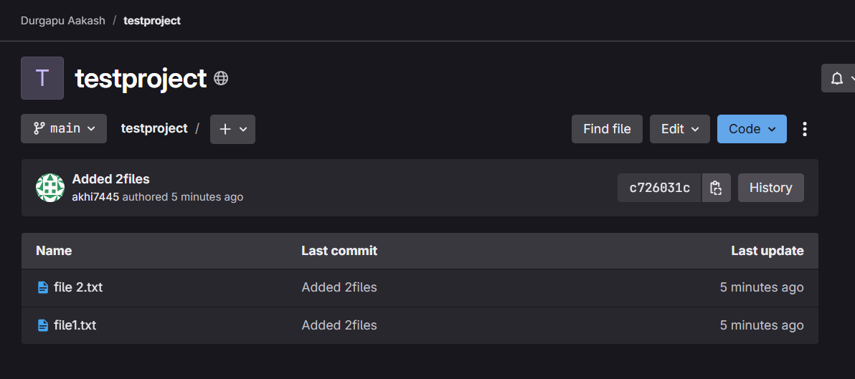

Changing to new folder

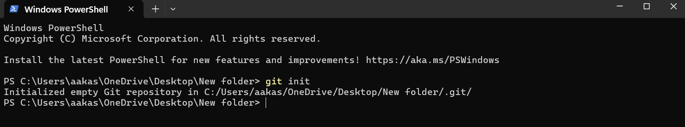

Cloning the two folders:

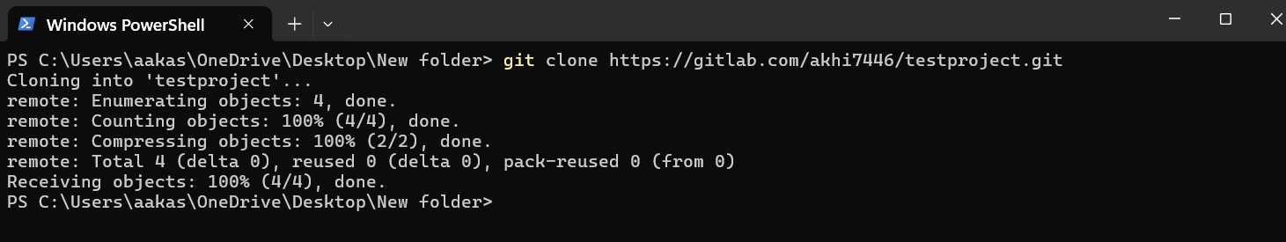

Added 3&4 files and pushed to gitlab :

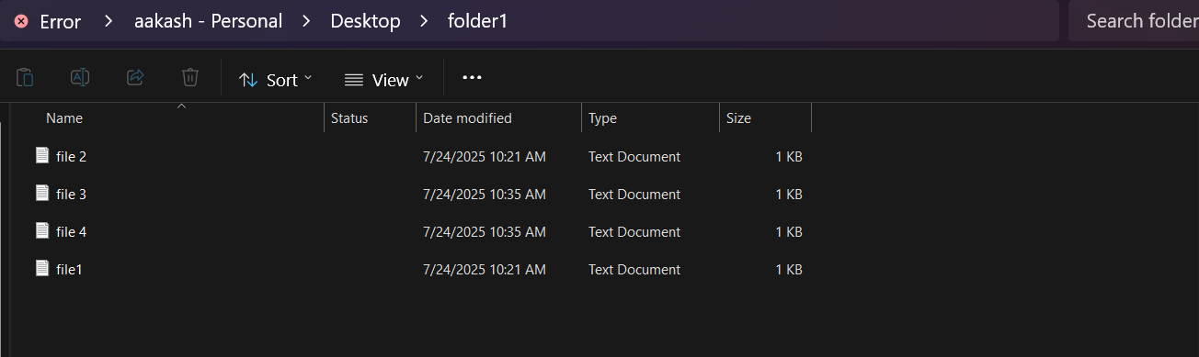

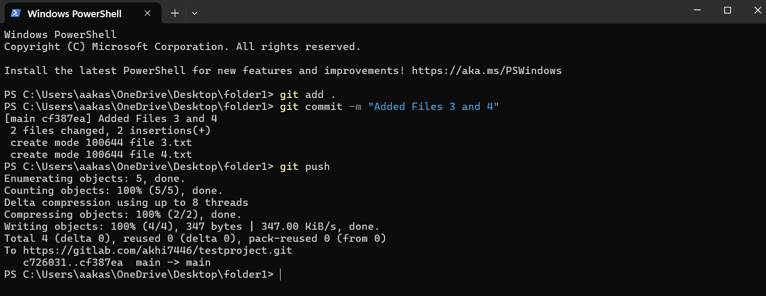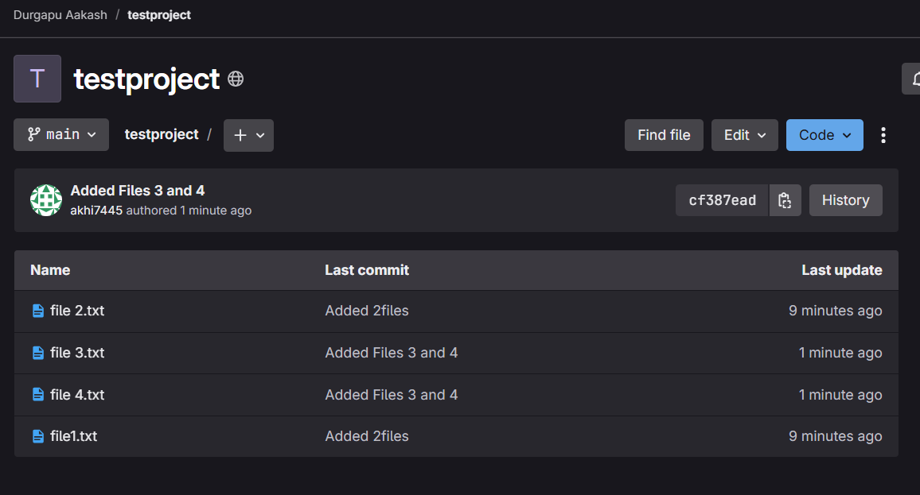

Changed Directory and Initialized Git pull:

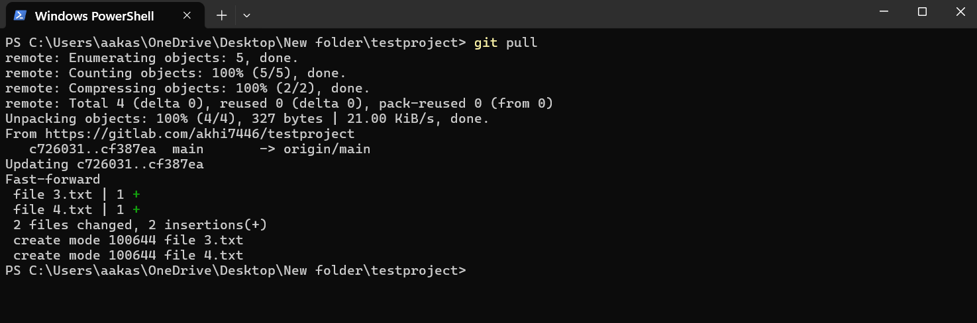

Output for Git Pull Command:

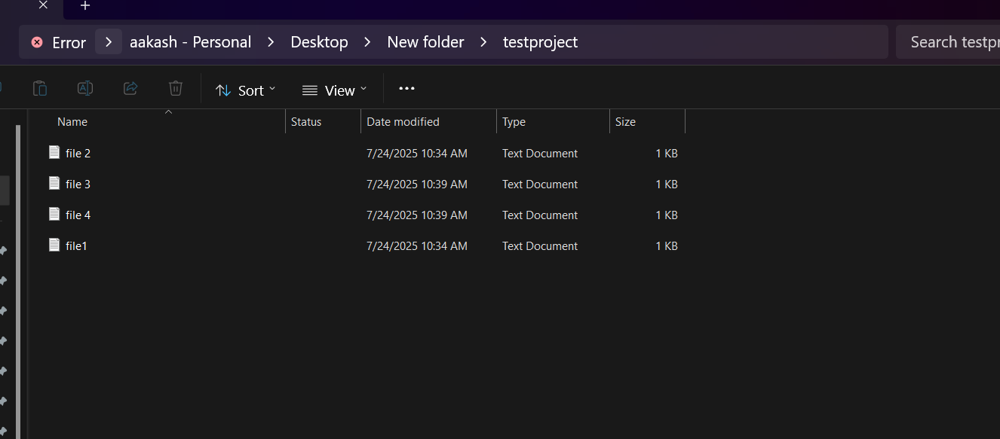

Here Is the GitLab Repo Link : <https://gitlab.com/akhi7446/testproject>